 | 14.1.11 Editors - Video Sequence Editor - Header - Text Menu
Table of content
Text menu 1
Edit Text 1
Cut Text 1
Copy Text 1
Paste Text 1
Move Cursor 1
Delete Character 2
Insert Line Break 2

Text menu

The Text menu contains text strip related functionality.
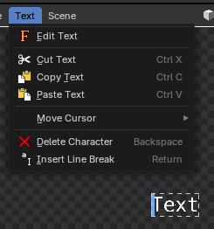
Note: This is only in the Preview mode of the Sequencer editor.

Edit Text
Toggles the text editing mode, so you can edit the text directly in the preview.

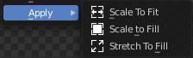
Cut Text
Cuts the selection.

Copy Text
Copies the selection.

Paste Text
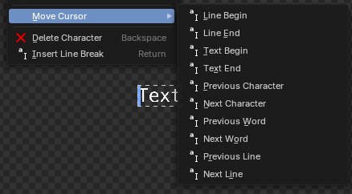
Pastes a copied selection.

Move Cursor
Set the cursor at specific positions in the text.
Note: These operators are typically done through arrow keys, page up/down and home/end keys.

Delete Character
Deletes the selected text.

Insert Line Break
Inserts a new line.

